

WEB SCRIPTING

CSE – 220 QUARTER V



September 26, 2020

M.Sathishkumar

E0119052

1. Analyse the following code fragments. Write about JS Engine phases (compilation and execution) for both fragments.

<script>

function fn() {

c = 10;

console.log(c);

}

console.log(c);

</script>

<script>

function fn() {

c = 10;

console.log(c);

}

fn();

console.log(c);

</script>

List out your Observations: if ***c*** is declared using ***var*** keyword

If ***c*** is declared using ***let*** keyword

If ***c*** is declared using ***const*** keyword

In the compilation state:

* First Snippet

The function fn() gets defined first and displays undefined as it doesn’t return anything (not executed now the fn function is called so variable c is defined and the console log works, also since the variable is declared without the keywords const, let, var these are in global scopes so the variable c can be accessed by the log statement outside of the function fn

* Second snippet

Unlike the first snippet the function is defined but not called so the variable c is not initialized with the value 10 so the compiler returns Reference error

If the variable let or const is used to initialize the variable c the variable will only reside in the function scope

1. Practice Arrow functions. Write at least three arrow functions and their corresponding anonymous functions.

Code:

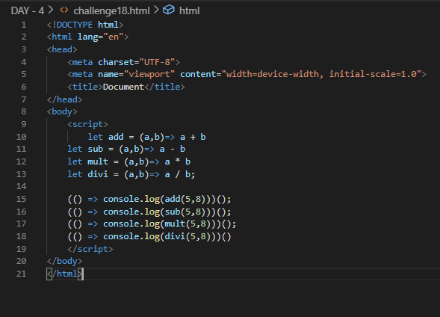

Output:

